Chapter 17, Problem 79.

Write a program to compute the Fourier coefficients (up to the 10th harmonic) of the square wave in Table 17.3 with A = 10 and T = 2.

Table 17.3 The Fourier series of common functions.
Function | Fourier Series
1. Square wave
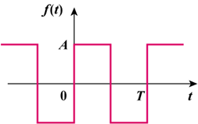 | 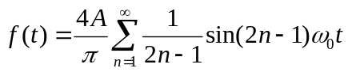
2. Sawtooth wave
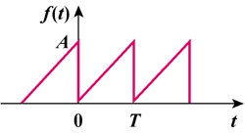 | 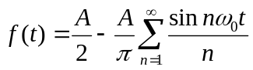
3. Triangular wave
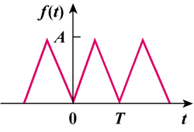 | 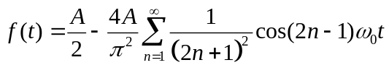
4. Rectangular pulse train
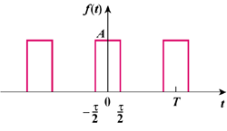 | 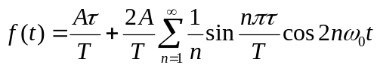
5. Half-wave rectified sine
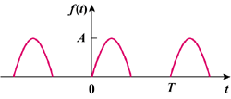 | 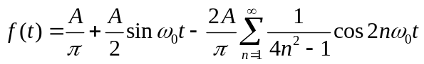
6. Full-wave rectified sine
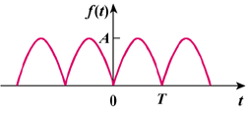 | 